**Asset List**

**Flora:**

Apple tree:

* Seedling
* Baby tree
* Mature tree

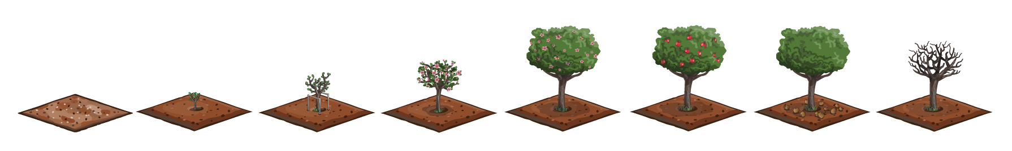

Carrots

* Seedling
* more leaves on carrot,
* ripe carrot (even more leaves)

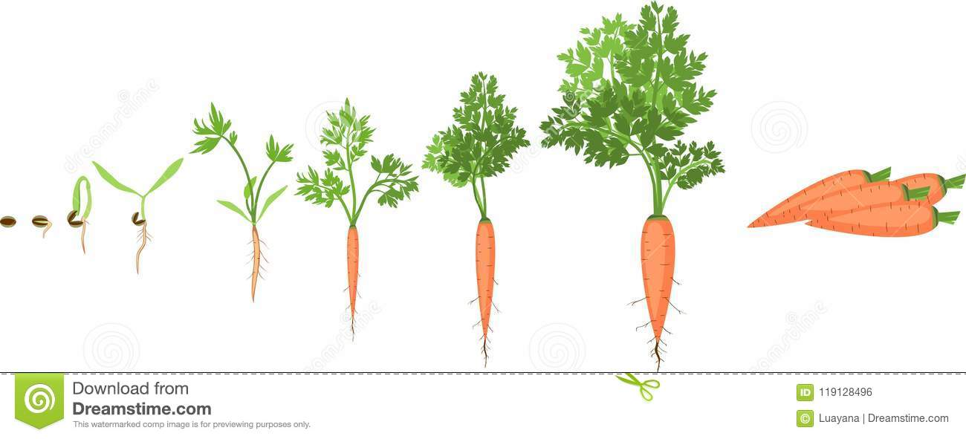

Berry Bushes (raspberry and blueberry)

* Bush with berries
* Bush without berries

Corn

* Seedling
* Leafier
* Ripe corn

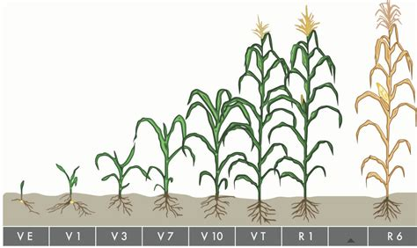

Lettuce

* Seedling
* Leafier
* Ripe Lettuce

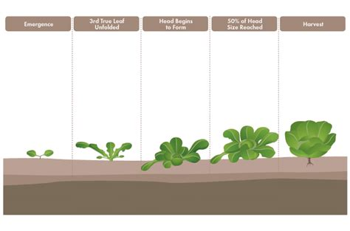

**Cooking related Assets:**

Apples

Carrots

Berries

Corn

Lettuce

The cooking Pot

A variety of sprites for the dishes made from the cooking

**Environmental Assets:**

Fence

Fence gate

Toiled Soil for crops

Plots for crops

**Assets that I forgot to add to this list**

* 2d fruit design
* 2d Veg design